

*sabzevar university of medical sciences*

***CURRICULUM VITAE***

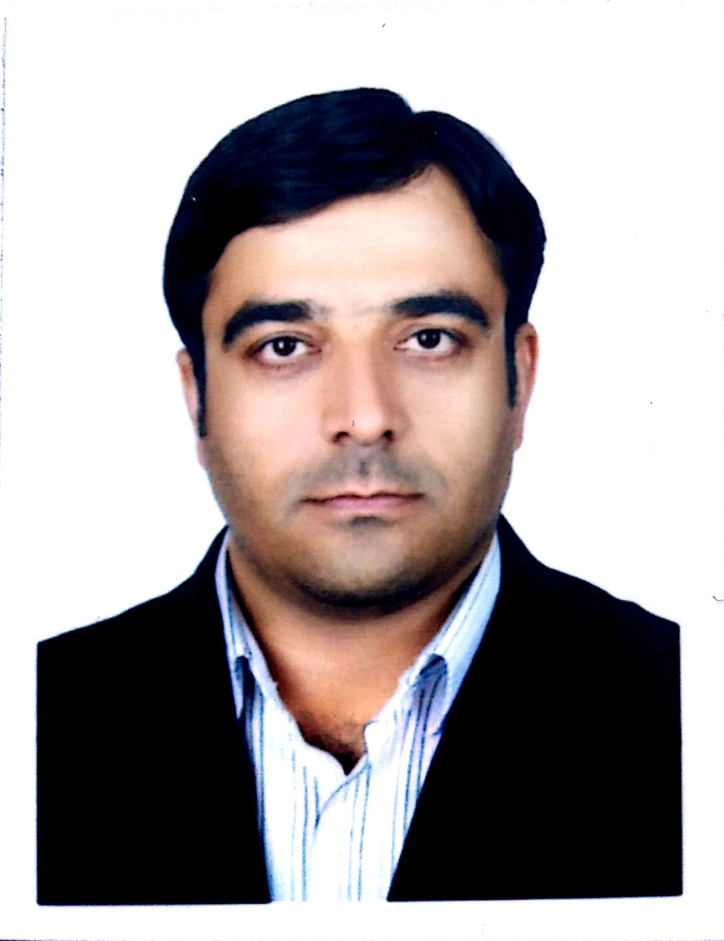

**PERSONAL INFORMATION**

**Name:** Alireza Ghorbani

**Affiliation:** Department of Public Health, School of Health, Sabzevar University of Medical Sciences, Sabzevar, Iran

**Tel:** *(office) +985144018434* **Fax*:*****+**985144018424

**Email:** ghorbania1474@yahoo.com

**EDUCATIONAL BACKGROUND**

**Ph.D. in** Health Economics

**MSc. in** Health Economics

**BSc. in** Public Health

**DISSERTATIONS**

**Ph.D. Thesis Title:**

Analyzing of economic effects of aging phenomena in Iran with emphasizing on social security system expenditure; an overlapping generation model.

**MSc Thesis Title:**

Estimation of the family demand function of dental cares in Sabzevar city: 2005

**TEACHING EXPERIENCES**

***I: Teaching Experiences I: Sabzevar University of Medical Sciences from 2012***

* Health Economics, Engineering Economics, Geographic Pathology, Economics of Incentive Care, Elderly Health, Health Management, Principles of Health Services Management

***II: Teaching Experiences II: the Islamic Azad University of Sabzevar from 2010 then 2014***

* Family Planning, Education Technology, Health Education

***III: Teaching Experiences III: Tehran University of Medical Sciences from 2012***

* Health Economics

**PROFESSIONAL MEMBERSHIP**

* Member of Public HealthDepartment, Faculty of Medicine, Sabzevar University of Medical Sciences. 2016 than in 2019.
* Member of Iranian Health Economics Association. 2005 then 2019
* Member of Khorasan Razavi Public Health Association. 2014 then 2017
* Manuscript Reviewer of:
* *Iranian Red Crescent Medical Journal*
* *International Journal of Virtual Learning in Medical Sciences*
* *Journal of North Khorasan University of Medical Sciences*
* *Journal of Sabzevar University of Medical Sciences*
* *Management Strategies in Health System*
* *Strides in Development of Medical Education*

**RESEARCH FIELDS OF INTERESTS**

* Economic Analysis of Diseases
* Efficiency and efficiency in the health system
* Economic Evaluation
* human resources
* Medical ethics
* Education Economics
* Population Economics
* **CONFERENCE PARTICIPATION**

1. **“**Iranian Conference on Infectious Diseases and Tropical Medicine**,”** Ghorbani A, Shegarf Nakhaie M, Tasbandi R. *Iran, Tehran,2007****.*** *(Oral presentation)*
2. " The Role of Women in the Development of the Health System,"Ghorbani A, Shegarf Nakhaie M, *Iran, Kermanshah,2008****.*** *(Oral presentation)*
3. *"* *Investigating the costs of traffic accidents in Sabzevar,"* Ghorbani A, Shegarf Nakhaie M*, Koshkbaghi R, Iran, Mashhad, 2007. (Oral presentation)*
4. *"* *Calculation of the cost of services provided at Sabzevar Health Center,"* Ghorbani A, Shegarf Nakhaie M, khoshhal M*, Iran, Kermanshah,2009****.*** *(Oral presentation)*

**PUBLICATIONS**

### **Ghorbani A**, Mirmosavi SJ, Mousavi SM, Atiehdoust S. [The Gap between the Students' Expectations and the Existing Educational Services at Sabzevar University of Medical Sciences, Using SERVQUAL Model‏](https://scholar.google.com/citations?view_op=view_citation&continue=/scholar%3Fhl%3Dfa%26as_sdt%3D0,5%26scilib%3D1&citilm=1&citation_for_view=AtALJH4AAAAJ:Y0pCki6q_DkC&hl=fa&oi=p). ***MEDIAJ*,** 2014;5(4)**.**

### [**Ghorbani**](http://www.ncbi.nlm.nih.gov/pubmed/?term=Ghorbani%20A%5BAuthor%5D&cauthor=true&cauthor_uid=26383202) **A**, [Raeissi](http://www.ncbi.nlm.nih.gov/pubmed/?term=Raeissi%20P%5BAuthor%5D&cauthor=true&cauthor_uid=26383202) P, [Saffari](http://www.ncbi.nlm.nih.gov/pubmed/?term=Saffari%20E%5BAuthor%5D&cauthor=true&cauthor_uid=26383202) E. Patient Satisfaction with the Family Physician Program in Sabzevar. ***GJHS***. 2016; 8(2).

### **Ghorbani A**, Raeissi P, Milani A. [Modeling the Cost of Population Aging in Iran‏](https://scholar.google.com/citations?view_op=view_citation&continue=/scholar%3Fhl%3Dfa%26as_sdt%3D0,5%26scilib%3D1&citilm=1&citation_for_view=AtALJH4AAAAJ:zYLM7Y9cAGgC&hl=fa&oi=p). ***GJHS***. 2016; 8(11).

1. **Ghorbani A**, Nabavi H, Khoshhal M, Husseini SH. Imposed costs due to traffic accident fatalities (a case study of Sabzevar). ***Traffic Management Studies***. 2011; 6(1).
2. Razavi SM, **Ghorbani A**, Kelate H. [Prevalence of job burnout and its relationship with workplace physical condition among the staff of Sabzevar university of medical sciences.](https://scholar.google.com/citations?view_op=view_citation&continue=/scholar%3Fhl%3Dfa%26as_sdt%3D0,5%26scilib%3D1&citilm=1&citation_for_view=AtALJH4AAAAJ:2osOgNQ5qMEC&hl=fa&oi=p)*JSUMS*. 2014; 20 (5).
3. Raeissi P, **Ghorbani A**, Tabarraie Y. Factors determining satisfaction with family practitioner program from the perspective of rural insurance card holders affiliated with Sabzevar University of Medical of Sciences. *JHA*. 2012; 15 (49).

### Hadian M, **Ghorbani A**, Ghiasvand H, Naghdi S. [Inequality in health and food expenditure, a study of Iranian urban and rural households‏](https://scholar.google.com/citations?view_op=view_citation&continue=/scholar%3Fhl%3Dfa%26as_sdt%3D0,5%26scilib%3D1&citilm=1&citation_for_view=AtALJH4AAAAJ:d1gkVwhDpl0C&hl=fa&oi=p).*JSUMS*. 2014; 20 (4).

1. **Ghorbani A**, Shegarf Nakhaie M, Dovlat Abadi A, Alemi H. Study of satisfaction rate of family medicine plan in insured population of Sabzevar university medical of sciences. *JSUMS*. 2014; 19 (4).
2. Ghaderi H, Jamshidi R, **Ghorbani A**. Estimation of dental services demand function of the family in Sabzevar, Iran, in the Urban Area. *JHA*. 2012; 13 (40).
3. Esmaeile R, Kianmehr M, Tahanzade A, Ehtiati M, **Ghorbani A**. Calculating the Unit Cost of Student Training at Gonabad University of Medical Sciences in 2017: Using a Step-Down Method. *Teb va Tazkiyeh***.** 2018; 27(3).
4. Naemi H, **Ghorbani A**, Ghazanfari SM, Masoudi far M, Koshkenaghi R. Factors affecting injury accidents within the city of Sabzevar in the years 2010- 2011. *JSUMS*. 2018; 25 (1).

**WORKSHOPS**

1. Workshop on "How to write a CV," Sabzevar university of medical sciences, *Sabzevar, Iran, September 2011.*
2. Workshop on "Strategic Planning," Sabzevar university of medical sciences, *Sabzevar, Iran, November 2014.*
3. Workshop on "Health Economics Principle for Hospital Managements," Sabzevar university of medical sciences, *Sabzevar, Iran, December 2018.*
4. Workshop on "Research Methods," Sabzevar university of medical sciences, *Sabzevar, Iran, September 2012.*

**EXPERIENCE**

**Computer Skills**

* Operating Systems: Windows

**Software:**

* ENDNOTE, Statistical analysis software (SPSS)
* Microsoft Office (Word, Powerpoint, Excel)
* DEA, SFA